Capomulin and Ramicane had the highest usage.

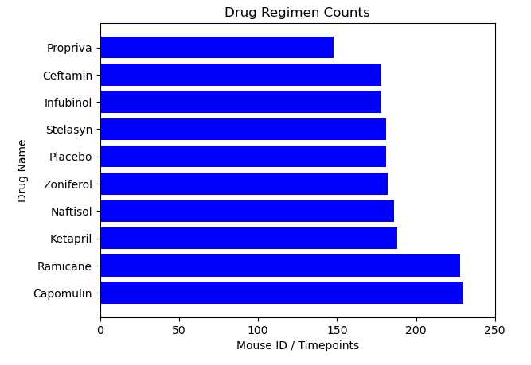

There was mostly an equal size in the population of males and females.

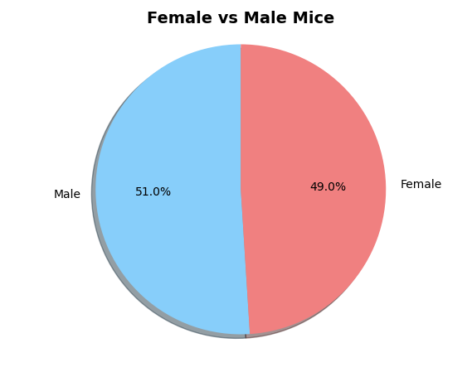

**Mouse m601** experienced a major decrease in the volume of the tumor over the course of 45 days.

